Date: 2024 TUESDAY
Batch: 2674724
Class DEVOPS
Time: 8am - 2pm
-------------------------------------

1.What is Cloud computing?
cloud computing is the on-demand delivery IT resource over internet with pay on you go pricing.
Instead of buying, owning and maintaining physical data center and servers.
we can access technology services such as compute power, storage, network etc...
on needed basis which is provided by cloud vendors like AWS, AZURE, GCP, IBM CLOUD

2.Difference Public, private and hybrid

3. Vocabulary and Terminology
Virtualization
Virtual Machine
API
Regions
Az
Scalability
High Availability
Disaster Recovery
Load Balancing

4. Different segments SaaS, PaaS, and IaaS
SaaS, PaaS, and IaaS are different segments of cloud computing services, each offering different levels of abstraction and management. Here's a brief overview of each:
1. SaaS (Software as a Service):
- Definition: SaaS provides software applications over the internet, eliminating the need for users to install, maintain, or manage the underlying hardware and infrastructure.
Examples: Google Workspace (formerly G Suite), Microsoft 365, Salesforce, Zoom.
- Amazon Chime: A communication service for online meetings, video conferencing, and business calling.
- Amazon WorkDocs: A secure enterprise document storage and sharing service.
- Amazon QuickSight: A business analytics service for creating and sharing data visualizations and insights.

- Usage: End-users access applications directly via the web or an API. The provider handles all aspects of maintenance, updates, and security.
2. PaaS (Platform as a Service):
- Definition: PaaS offers a platform that allows developers to build, run, and manage applications without worrying about the underlying infrastructure. It includes operating systems, databases, development frameworks, and more.
Examples:
- AWS Elastic Beanstalk: An easy-to-use service for deploying and managing applications. It automatically handles the details of capacity provisioning, load balancing, scaling, and application health monitoring.
- AWS Lambda: A serverless computing service that allows you to run code in response to events without provisioning or managing servers.
- Amazon RDS (Relational Database Service): A managed database service that supports several database engines like MySQL, PostgreSQL, Oracle, and SQL Server.
- Usage: Developers use PaaS to focus on coding and application logic. The provider manages servers, storage, networking, and other resources.
3. IaaS (Infrastructure as a Service):
- Definition: IaaS provides virtualized computing resources over the internet, such as virtual machines, storage, and networking. It offers the most flexibility but requires users to manage more aspects of the system.
- Examples: Amazon Web Services (AWS EC2), Microsoft Azure Virtual Machines, Google Compute Engine.
- Usage: Users have control over operating systems, storage, and deployed applications, but the provider manages the underlying hardware.

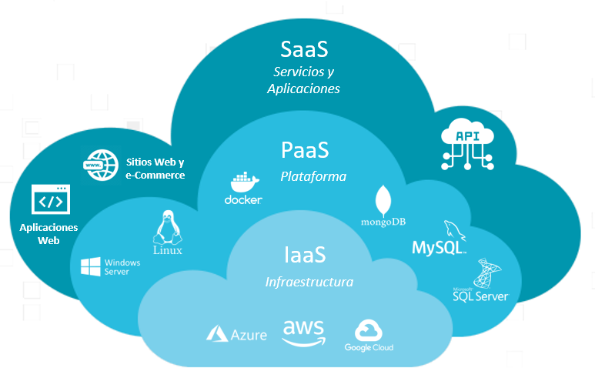

Comparison:
- SaaS: Ready-to-use applications.
- PaaS: Platform for building applications.
- IaaS: Infrastructure for hosting any applications.
These segments provide different levels of control and responsibility, catering to various user needs from simple software usage to full-scale infrastructure management.

5. Launch EC2 Instance

